

Located at Plot 56, Ambassador House, 60 Kampala Road
P.O Box 126203, Kampala (Uganda)
Tel: +256-752-881000
WhatsApp: +256-752-881000
E-mail: freeindeedministriesint@gmail.com
ORGANIZATIONAL PROFILE
Free Indeed Ministries is an Evangelical Christian, Bible-believing, non-denominational, politically non-partisan, charitable, and non-profitable ministry and missionary organization operating in Uganda. It is registered with The Government of Uganda and the ministry exists primarily as a voice to support and nurture the effective growth and development of the Pentecostal movement through networking, capacity building and enabling strategic partnerships. The Ministry has over 120 church leaders, 62 member churches and these are all actively inspired by the Holy Spirit to LOVE, REACH-OUT AND SERVE. The Ministry was founded on 3rd April 2015 and officially registered by The Government of Uganda on 15th May 2018 spear headed by Pastor Arthur Mukisa, who came up with the objective to spread the gospel, fight poverty and help the most vulnerable groups of orphans, children, youth, and disadvantaged women, in promoting their rights and in so doing achieving a better future. The ministry embraces the core values of Christianity and presents them in an honest, intelligent, brave and fun way through UP-RIGHT LIVING, COVENANT LIVING and SERVICE.

It’s a Christian faith-based organization inspired by Christian values, which conducts projects in different parts of the world, mainly East Africa to bring changes in evangelism, preaching the gospel, returning the lost souls to our Lord Jesus Christ, reducing poverty, promoting education, enabling the sustainable development of communities, and achieving dignity for all irrespective of their sex, age, tribe, religion, or political background. Another motivating factor for the ministry in Uganda is the noted reduction of interest by the local and international humanitarian agencies and institutions in aiding the less privileged in the religious sectors in the central, western and eastern regions of Uganda especially in the areas of Kampala, Wakiso, Masaka, Mbarara, Iganga and Busukuma.

The ministry is committed and promises to help the vulnerable groups of orphans, children, youth, and disadvantaged women to improve capacity building; in order to create participation in development at Christian community levels. Free Indeed Ministries also yearns to join the team of visionaries who aim to impact and develop the Christian faith-based sectors all over the world. Many districts in Uganda have seen deteriorations in many areas especially at community levels. Also there have been many instances of concern where humanitarian activities haven’t been implemented as projected. The Government authorities and religious institutions who have promised to bring certain developments, improvements or interventions have in many cases failed the people and this goes a long way to affect the livelihood of the marginalized persons economically, spiritually and socially. The organization has a great passion and is diligent in intervening to provide services to make a difference and a great impact to the Christian communities.

Leadership Structure of Free Indeed Ministries

Free Indeed Ministries has an overseer and vision bearer as Pastor Arthur Hashim Mukisa. Pastor Arthur Hashim Mukisa is also the founder of the Ministry with Pastor Henry Mukisa as the chairperson of the ministry, Pastor John Sewankambo as the vice chairperson as and Pastor Sekandi Julius as the ministry administrator.

Free Indeed Ministries has leadership across regions, country and district. These include overseers, administrators and secretaries who run various projects.

VISION STATEMENT

We are the River of Life (Rev 22:1-2), to bring life to the nations through preaching the gospel of our Lord Jesus Christ as commanded (Matthew 28:19-20, John 20:21) and bringing revival to the body of Christ.

MISSION
To evangelize and transform the whole world through love, outreach, and service to alleviate the suffering of those in need and build a community with a Jesus-like character.

GOAL
To change lives by providing high impact oriented, cost effective, & faith based competent capacity building programs to people in the world particularly the youth, widows, orphans and children of school going age.

OBJECTIVES:

- Free Indeed Ministries is devoted to reviving, empowering, and equipping the local church and the people of God to produce a lasting transformation. (1Peter 4:9-10, Haggai 1:3-10).

- To facilitate the formation of vibrant small community groups through the Gideon, Dorcas, and Joshua projects, where members exchange views and information to effectively identify, plan, implement and evaluate their development concerns and initiatives (Proverbs 19:17).

- To organize trainings to empower and conduct programs aimed at initiating self-help interventions among local communities, helping them overcome poverty, H1V/A1DS pandemic, food shortage, environmental degradation, poor water and sanitation, human rights violations, and to improve education and livelihoods of vulnerable groups for increased progress and human dignity (Matthew 25:40-46).

- To undertake lobbying, advocacy, and networking with partner organizations on identified pertinent issues.

- To build schools and hospitals which strengthen the institutional capacity to effectively carry out community programs and respond timely and effectively to community challenges and needs (Haggai 1:3-10).

CORE VALUES:
- UPRIGHT LIVING
We believe in living holistically and righteously as Jesus Christ did, so that we receive the grace to live for God and not to lose eternity. (Dan. 1:8; Acts 24:16; 1Tim. 4:1-2;)

COVENANT LIVING
We believe in living according to God’s covenant (the word of God): Not bowing to any other God, tithing, evangelism, helping the needy and others. (Joshua 1:8, Ephesians 2:8-10; Exodus 20:4-6, Exodus 23:24)

SERVICE LIVING
We believe in living a life of service to God, serving God is serving others. (Matthew 25:40, Exodus 23:25)

PEOPLE-CENTERED
Free Indeed Ministries, we create relationships with different churches and project groups in building the kingdom of God. Just as many hands are better than one, our programs and other interventions put people first, and value their concerns and contributions to promote their dignity and 'livelihoods.

EQUALITY
We treat all people equally with due respect: foster positive neutrality on ideological issues.

TEAMWORK
We promote groups and individuals working together as a team: encourage the spirit of collective responsibility, sharing knowledge and resources for the common good.

TRANSPARENCY
We build people’s confidence and trust by promoting accountability and integrity, an open and transparent manner in the conduct of our public affairs.

JUSTICE AND LOVE
We love to perform duties in a fair way and advocate for the voiceless, especially vulnerable community groups whose rights are violated.
FREE INDEED MINISTRIES PROJECT FOCAL AREA: ADVOCACY/AWARENESS PROJECTS
  - EDUCATION: Joshua Project: marginalized youth & Gideon Project: vulnerable and orphan children.
  - WOMEN EMPOWERMENT PROGRAMME: Dorcas Project for the disadvantaged women.
  - EVANGELISM: Outreach Ministry & evangelism ministry i.e. the prayer camp, End of year Holy Spirit conference, Night of Glory etc.

GOOD GOVERNANCE AND ACCOUNTABILITY: Leadership conferences.

PROJECTS:
Over the years Free Indeed Ministries readied local communities with the following services and program activities

EVANGELISM
While ensuring that this project comes to pass, we embarked on various activities such as:

OUTREACH MINISTRY
- ANNUAL PRAYER CAMP
- NIGHT OF GLORY
- END OF YEAR HOLY SPIRIT CONFERENCE
In December we hold our end-of-year international conference which takes place in Mbarara (western Uganda) during the second week of December.

A. OUTREACH MINISTRY
The outreach program is the core ministry of Free Indeed Ministries (Mathew 28:19-20, John 20:21). Through this ministry, other projects were birthed, and it has turned out to be the most exciting part of our ministry. Since 03/04/2015, Free Indeed Ministries has been holding outreaches in different communities within Uganda under different churches that invite and relate with us.
When selecting where the outreach will occur, the ministry committee sits at the beginning of the year and outlines all possible available options for pastors and churches interested. The committee carefully scrutinizes the list to get only eleven (11) churches or communities for a year. After the scrutinizing process, the church/community leaders of the selected place are notified. Notifications are made every month of where the outreach is to happen next. Church and community leaders are kept in the know about everything transpiring in the ministry. It is done every last Saturday from January to November.
Note: If the host church or community finds itself not in a position to host us, prior communication is made, and the opportunity is given to someone else.
During the outreach, we go door to door evangelizing the community; we usually have time for prayer, praise, and worship, inclusive of charity works, like donating item from our partners. Such items include: Clothing items (new and used), food items and toys for the children.

PICTORIAL OF THE OUTREACH
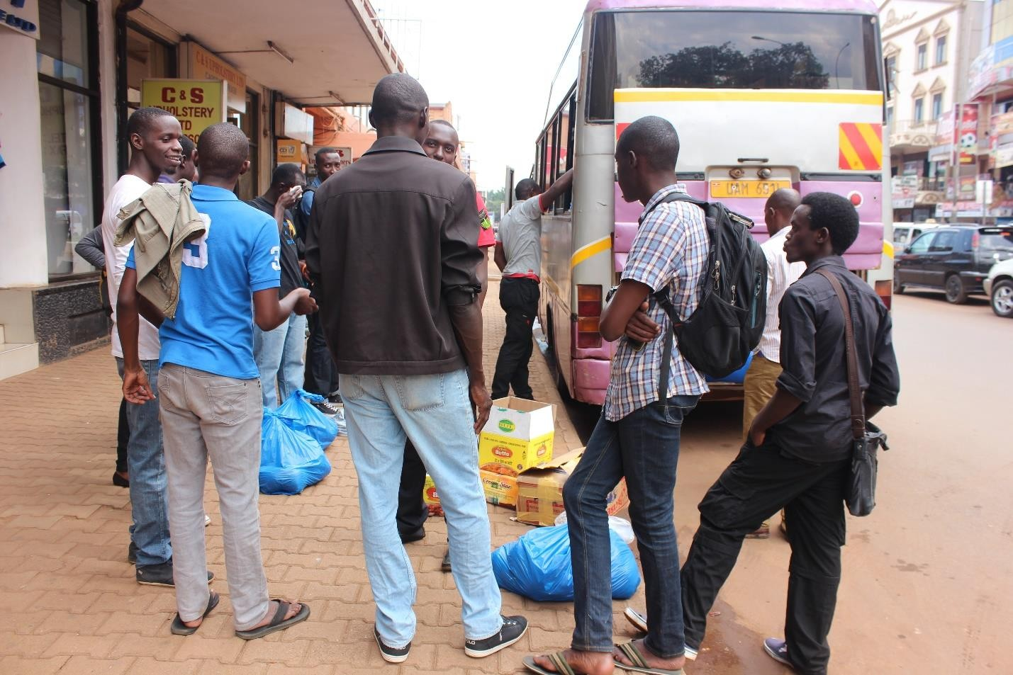
Some of the Outreach members gathering at the set-off point at the Buganda Road in year 2015

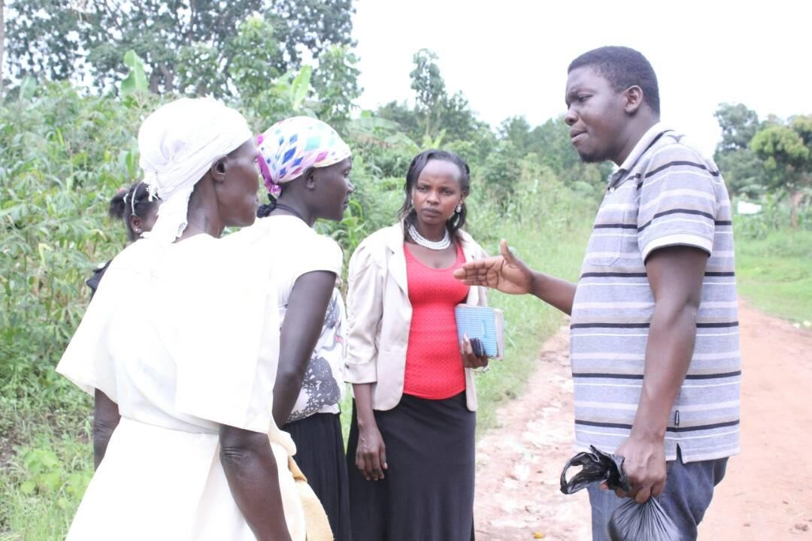
A team member preaching the gospel to the residents of Kakiri Town Council
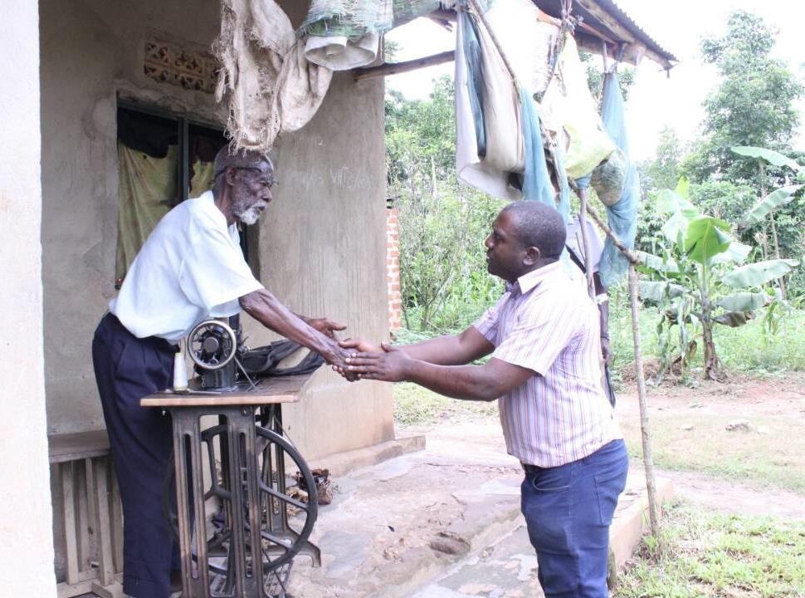
Conducting outreach in Kyanuuna Village, Namayumba Subcounty in Wakiso District.

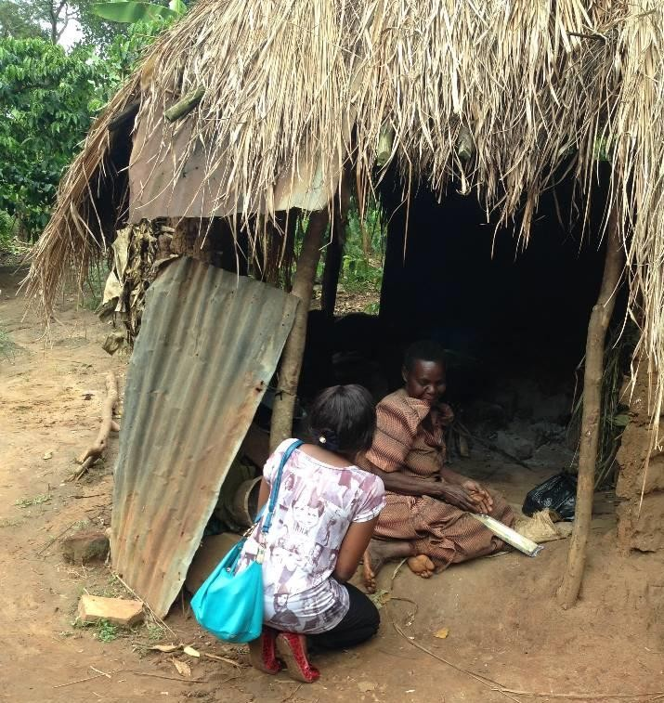
Reaching out to an old woman who gave her life to Jesus Christ, the grass thatched house was her shelter before constructing for her a one roomed house in Kiboga District in 2016.

ANNUAL PRAYER CAMP
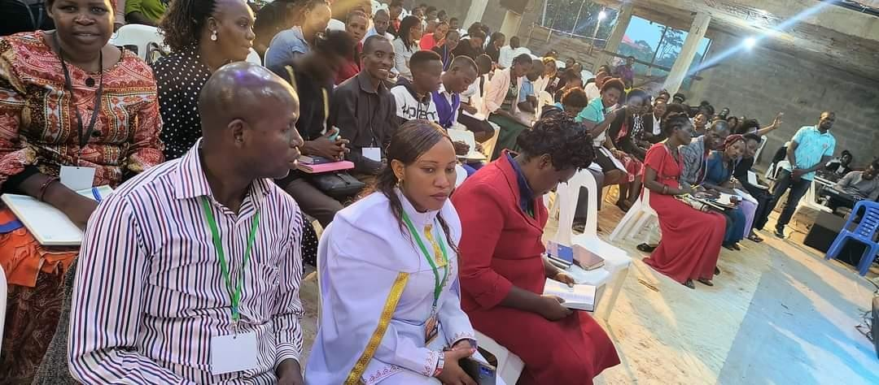
June is an important month for Free Indeed Ministries. During this month, we are joined by believers from all over the world in a prayer camp gathering called “Rebuilding the Walls” (Nehemiah 1:3, Nehemiah 2:5). We take a week to separate ourselves in a consecrated place for prayer and devotion to God. During this week, we pray and fast as guided by our leader. In addition, we usually reach out to people in the community we are camping in. We conclude the camp with door to door, person to person, and open-air evangelizing. The last gathering was in Namilyango Seeta in Mukono District with about 500 churches and approximately 1,700 people and among the congregation were participants from other East African countries.

Delegates from Kenya attending the Annual Prayer Camp at Namilyango-Seeta 2023

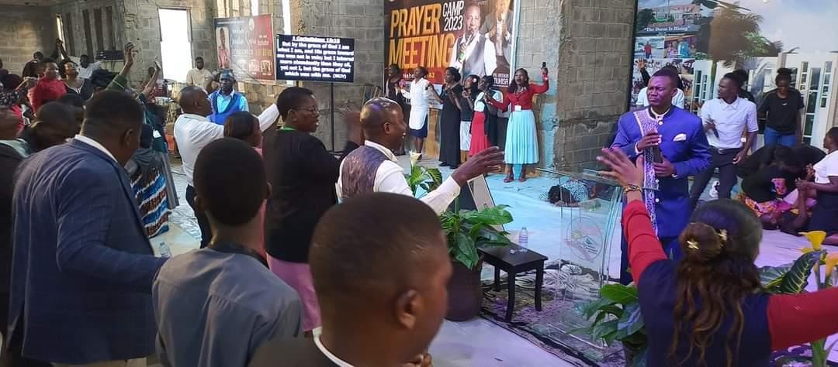
Praise and Worship during the 2023 Annual Prayer Camp at Seeta

NIGHT OF GLORY
Free Indeed Ministries believes that an hour spent in the presence of God counts more than the time spent elsewhere. Apart from evangelism and a prayer camp, Free Indeed Ministries is involved in prayer and worship gatherings. Every second Friday of a month, the Ministry holds a prayer night, known as a 'NIGHT OF GLORY,' in Kampala (Capital city of Uganda) from 6 pm to 6 am. We conduct praise and worship, prayer, intercession, devotion, word, and deliverance.

END OF YEAR HOLY SPIRIT CONFERENCE
This is an international conference where leaders from various countries are hosted in Uganda Mbarara District in the western part of the country. During this conference, training in leadership, evangelism and administration is conducted as a way of preparing ourselves for the new year. This conference in the presence of the Holy spirit involves deep prayer and worship sessions from 8 am to late in the night. It is characterized by massive testimonies for the congregants.
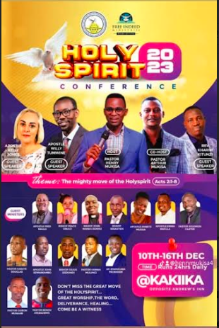
The 2023 Holy Spirit Conference was held from 10th to 16th December 2023.

    - GIDEON PROJECT
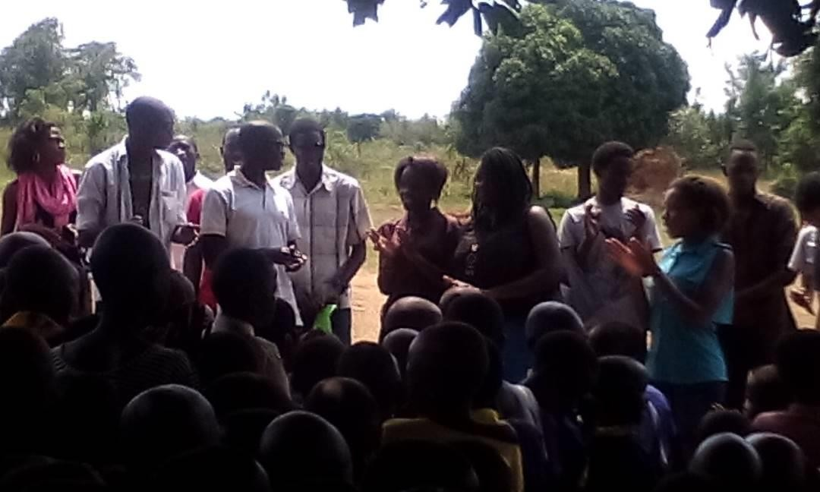
Free indeed is actively involved in bringing transformation of lives in Uganda. Individual attitudes and behavior can be influenced by religiosity and spiritual well-being through different dimensions like belief, emotional involvement, and guidance. We assist orphans and needy children, especially those who live with single mothers, with basic needs and education. Assist abandoned children in finding foster homes and families for better spiritual and God-fearing upbringing. Reduce stigma against vulnerable groups of people in their communities including homeless children, orphans and children living with disabilities, mental sicknesses or chronic illnesses thus bringing healing and restoration to children and their families through counseling, guidance and prayer.

School at Budaali Village Namayumba Sub County interacting with our team in year 2015

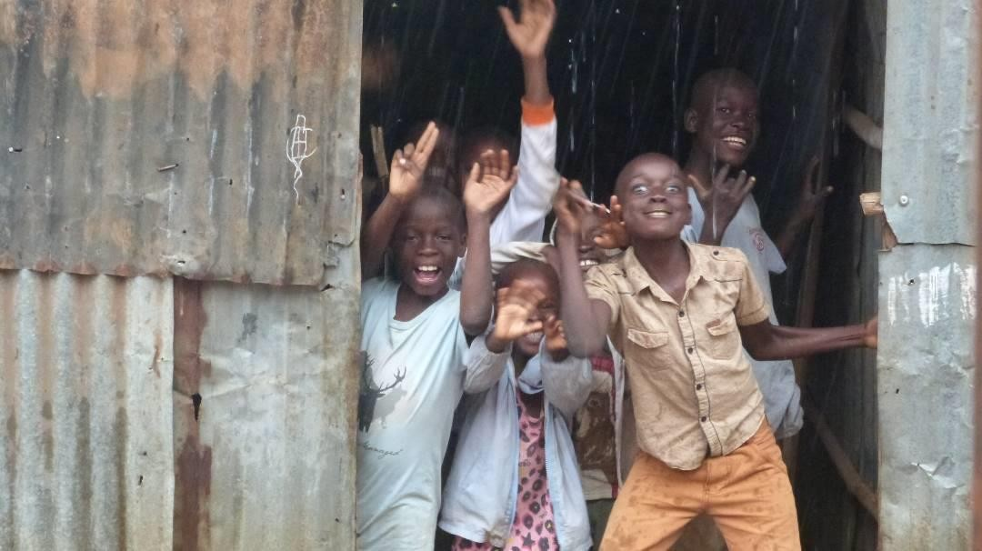
Sponsored children at our school “Destiny Children School” at Kyanuuna Village in Namayumba Sub County Wakiso District.
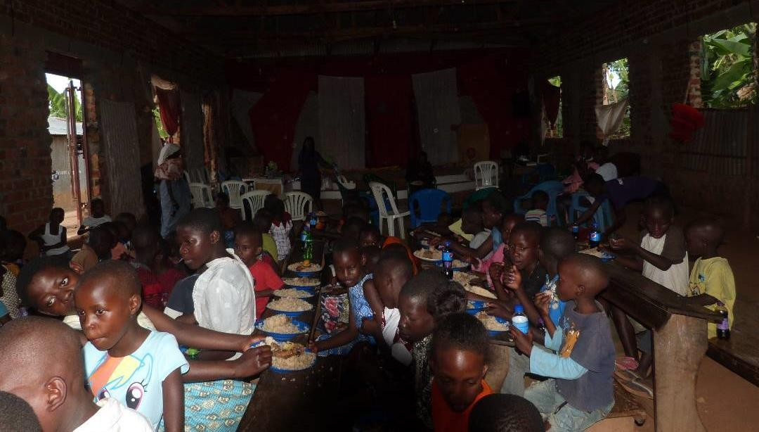
Lunch being served to the children during our Gideon Projecrt

JOSHUA PROJECT
Free Indeed Ministries aims to ensure that young people (youth) who are vulnerable and underserved can receive a brighter future through building a supportive, positive and open-minded environment for our youth. In this project, young men and women are not only taught to serve God but also taught how to become entrepreneurs and leaders, like teaching our beneficiaries sustainable ways of living through skill trainings for purposes of being job creators and inventors. In order for the ministry to achieve its goal we carry out peer counseling sessions and awareness with an aim of preventing ridiculous acts and bad company.
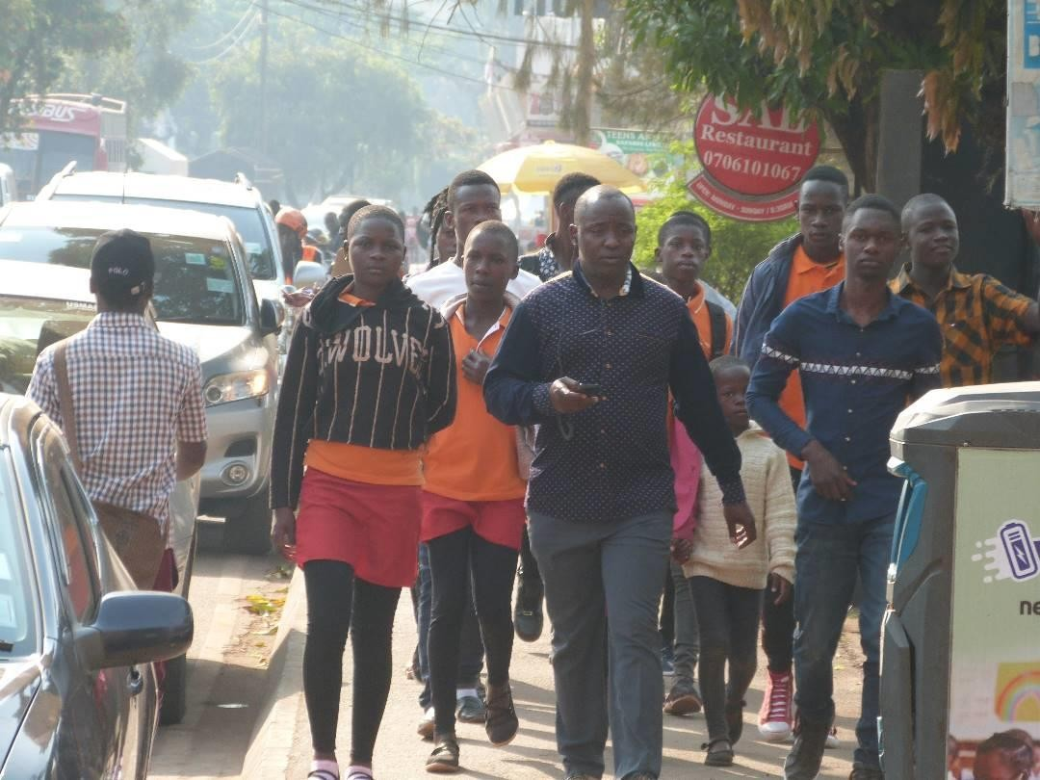
Youth getting ready for the engagement exercise.
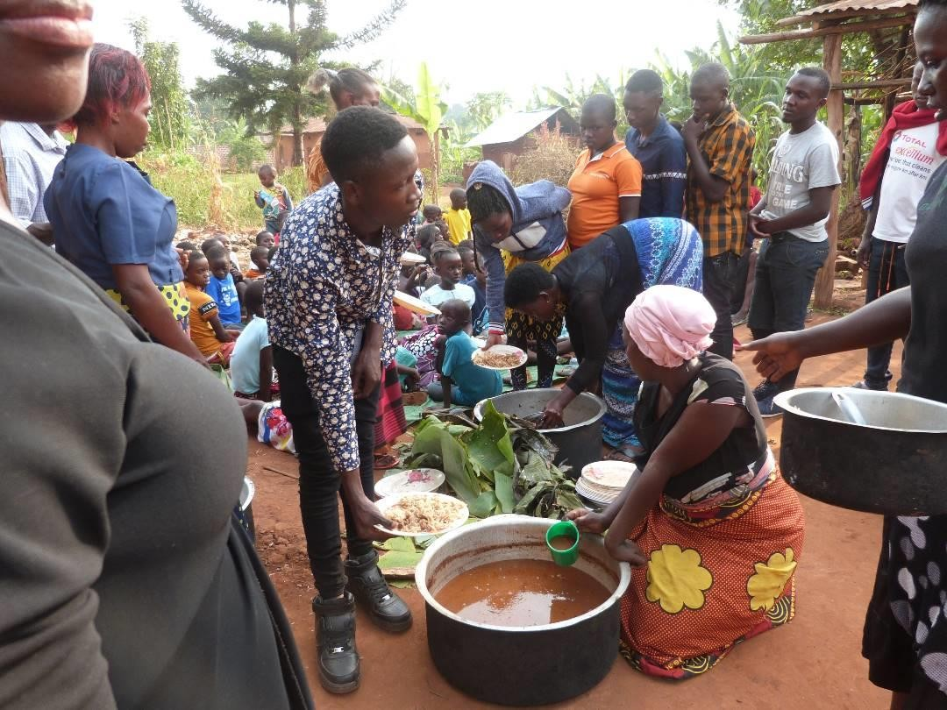
Youth extending a hand to the women while giving lunch to the vulnerable community of widows and children.

DORCAS PROJECT
Provide better opportunities for the widows/women through sustainable small scale income generating projects; conducting all other activities that shall be conducive or incidental to the attainment of the organization objective. To support vulnerable women in churches and communities, especially widows, deserted, single mothers, aged and disabled. Through setting up small businesses for them like poultry farming, retail shops, market stores among others. Free Indeed Ministries shall also encourage them to join home cell fellowships in order to grow spiritually and empower them on other mode of survival/livelihood.

In a nutshell, above is the brief of the do’ s of the church having highlighted the activities of the church.

.............................................. ARTHUR MUKISA HASHIM OVERSEER& PASTOR
FREE INDEED MINISTRIES

